Project Design Phase

Solution Architecture
Date | 09 July 2026
Team ID | SWTID-2026-3267
Project Name | SB Stocks
Maximum Marks | 4 Marks

Solution Architecture
SB Stocks is designed using a four-tier MERN architecture. The React frontend communicates with Express REST APIs secured using JWT. The business layer performs paper trading, portfolio management, watchlist management and live market simulation. MongoDB stores users, stocks, portfolios, transactions and watchlists for scalable data persistence.

Architecture Diagram
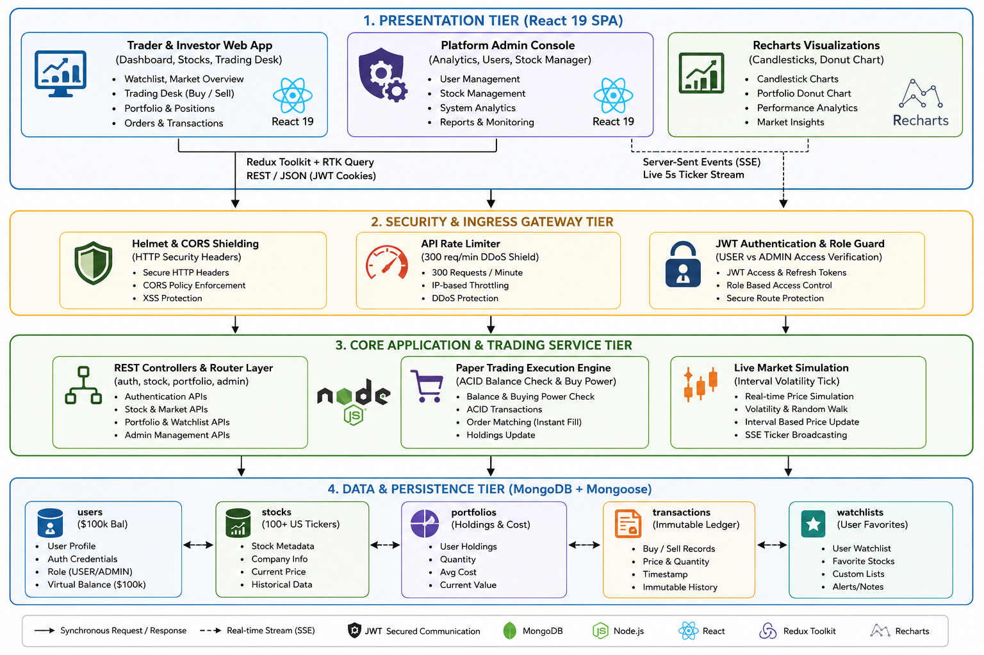
Figure 1: SB Stocks Solution Architecture

Architecture Description
- Presentation Tier: React dashboard, admin console and Recharts visualizations.
- Security Tier: Helmet, CORS, API rate limiting and JWT role-based authentication.
- Core Application Tier: Express controllers, paper trading engine and market simulation.
- Data Tier: MongoDB collections for users, stocks, portfolios, transactions and watchlists.

